**Semester 1 (Unit 3) Examination, 2020**

**Question/Answer Booklet**

**MATHEMATICS METHODS**

**Section One: Calculator-free**

Student Name/Number: ______________________________________________

Teacher Name: ______________________________________________

**Time allowed for this section**

Reading time before commencing work: five minutes

Working time for this section: fifty minutes

**Materials required/recommended for this section**

**To be provided by the supervisor:** This Question/Answer Booklet

Formula Sheet

**To be provided by the candidate:**

Standard items: pens (blue/black preferred), pencils (including coloured), sharpener,

correction fluid/tape, eraser, ruler, highlighters

Special items: nil

**Important note to candidates**

No other items may be taken into the examination room. It is **your** responsibility to ensure that you do not have any unauthorised notes or other items of a non-personal nature in the examination room. If you have any unauthorised material with you, hand it to the supervisor **before** reading any further.

**Structure of this paper**

|  |  |  |  |  |  |
| --- | --- | --- | --- | --- | --- |
| Section | Number of questions available | Number of questions to be answered | Working time (minutes) | Marks available | Percentage of exam |
| Section One: Calculator-free | 7 | 7 | 50 | 50 | 35 |
| Section Two: Calculator-assumed | 12 | 12 | 100 | 100 | 65 |
|  | | | | | 100 |

**Instructions to candidates**

1. The rules for the conduct of School exams are detailed in the School/College assessment policy. Sitting this examination implies that you agree to abide by these rules.
2. Write your answers in this Question/Answer booklet preferably using a blue/black pen. Do not use erasable or gel pens.
3. You must be careful to confine your answer to the specific question asked and to follow any instructions that are specified to a particular question.
4. Show all your working clearly. Your working should be in sufficient detail to allow your answers to be checked readily and for marks to be awarded for reasoning. Incorrect answers given without supporting reasoning cannot be allocated any marks. For any question or part question worth more than two marks, valid working or justification is required to receive full marks. If you repeat any question, ensure that you cancel the answer you do not wish to have marked.
5. It is recommended that you do not use pencil, except in diagrams.
6. Supplementary pages for planning/continuing your answers to questions are provided at the end of this Question/Answer booklet. If you use these pages to continue an answer, indicate at the original answer where the answer is continued, i.e. give the page number.
7. The Formula sheet is not to be handed in with your Question/Answer booklet.

**Section One: Calculator-free (50 Marks)**

This section has **(seven)** **7** questions. Answer **all** questions. Write your answers in the spaces provided. Spare pages are included at the end of this booklet.

Suggested working time: **50 minutes**.

**Question 1 (7 marks)**

(a) Determine  given that  (2 marks)

(b) Determine  given that  (2 marks)

(c) Evaluate  given that  (3 marks)

**Question 2 (10 marks)**

Suppose that .

(a) Determine the exact values of all zeros of  (2 marks)

(b) Determine the location and nature of all stationary points and points of inflection of 

(4 marks)

(c) Determine the maximum value of  for  (1 mark)

(d) Sketch on the axes below the graph of  where  (3 marks)

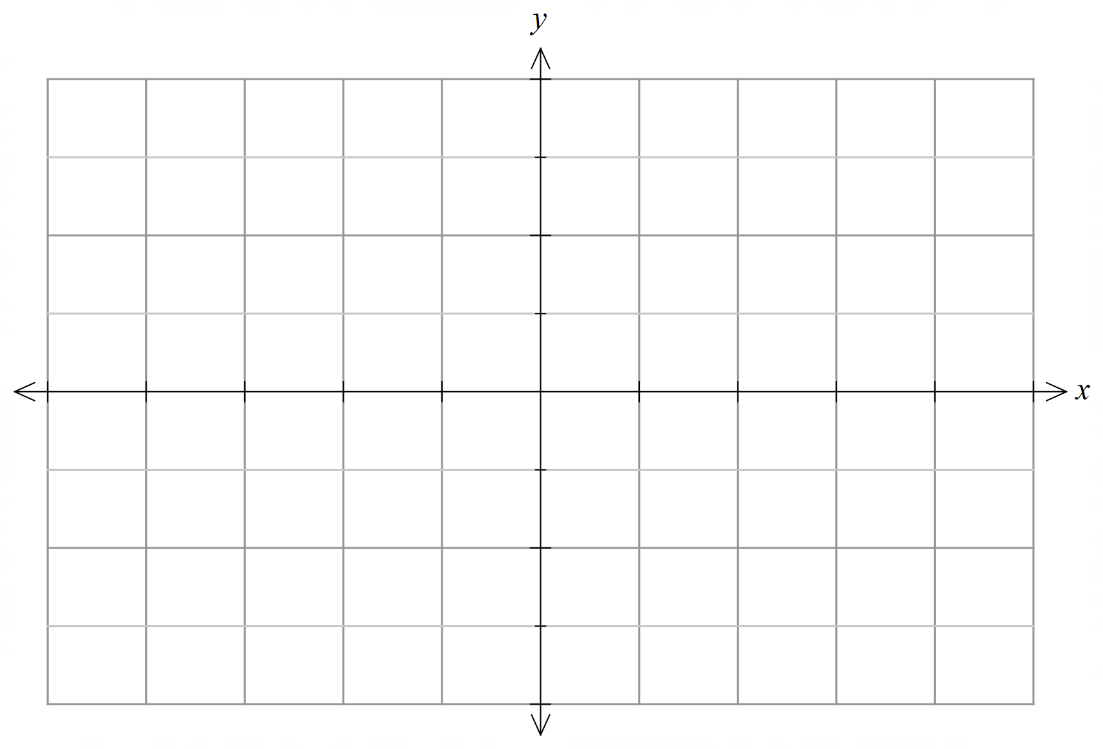

**Question 3 (5 marks)**

Given that , determine

(a) the instantaneous rate of change of *c* with respect to *x* when *x* = 2. (1 mark)

(b) the change in *c* when *x* changes from to  (4 marks)

**Question 4 (6 marks)**

A discrete random variable *X* has the probability function,  given by

 

(a) Show that  (2 marks)

(b) Determine  (2 marks)

(c) Determine  (2 marks)

**Question 5 (12 marks)**

(a) (i) Evaluate  (2 marks)

(ii) Determine  (2 marks)

(b) Given that is continuous everywhere and and ,

determine,

1.  (1 mark)
2.  (2 marks)

(c) By considering the derivative of show that the value  makes true, where *C* is an arbitrary constant. (5 marks)

**Question 6 (5 marks)**

(a) The derivative function  for the function is of the form,



Determine the value of and  (3 marks)

(b) The tangent to the curve  at the point B is parallel to the $x$ axis.

State the coordinates of B. (2 marks)

**Question 7 (5 marks)**

The graphs of  and over the domain  are drawn below.

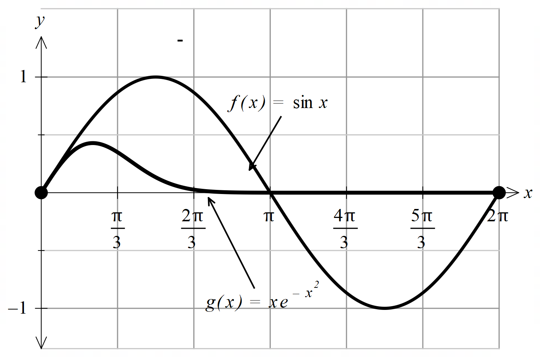

(a) Explain what is meant by the expression given below: (2 marks)



(b) Determine  (3 marks)

Supplementary page

Question number: ______________________

© MAWA, 2020

This examination is Copyright but may be freely used within the school that purchases this licence.

* The items that are contained in this examination are to be used solely in the school for which they are purchased.
* They are not to be shared in any manner with a school which has not purchased their own licence.
* The items and the solutions/marking keys are to be kept confidentially and not copied or made available to anyone who is not a teacher at the school. Teachers may give feedback to students in the form of showing them how the work is marked but students are not to retain a copy of the paper or the marking guide until the agreed release date stipulated in the purchasing agreement/licence.

*Published by The Mathematical Association of WA*

*12 Cobbler Place, MIRRABOOKA 6061*